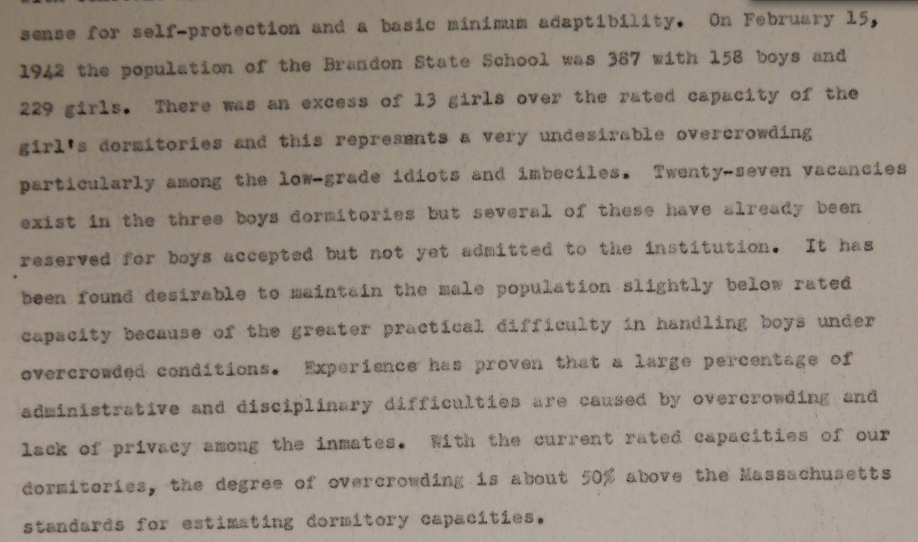

overcrowding – different implications for boys and girls – sexual in nature?

Possible sexual subtext to the following: “It has been found desirable to maintain the male population slightly below rated capacity because of the greater practical difficulty in handling boys under overcrowded conditions. Experience has proven that a large percentage of administrative and disciplinary difficulties are caused by overcrowding and lack of privacy among the inmates.”

A.D. Barnard, "The Problem of Insufficient Institutional Facilities for the Care of Mental Defectives in Vermont,” circa 1942, 6. Vermont State Archives.

