Folder: Mental Health Program

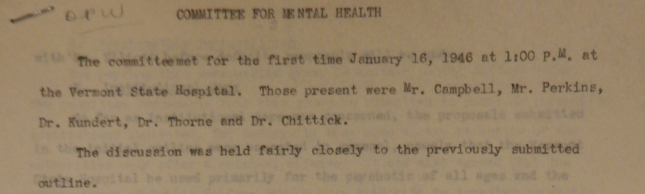

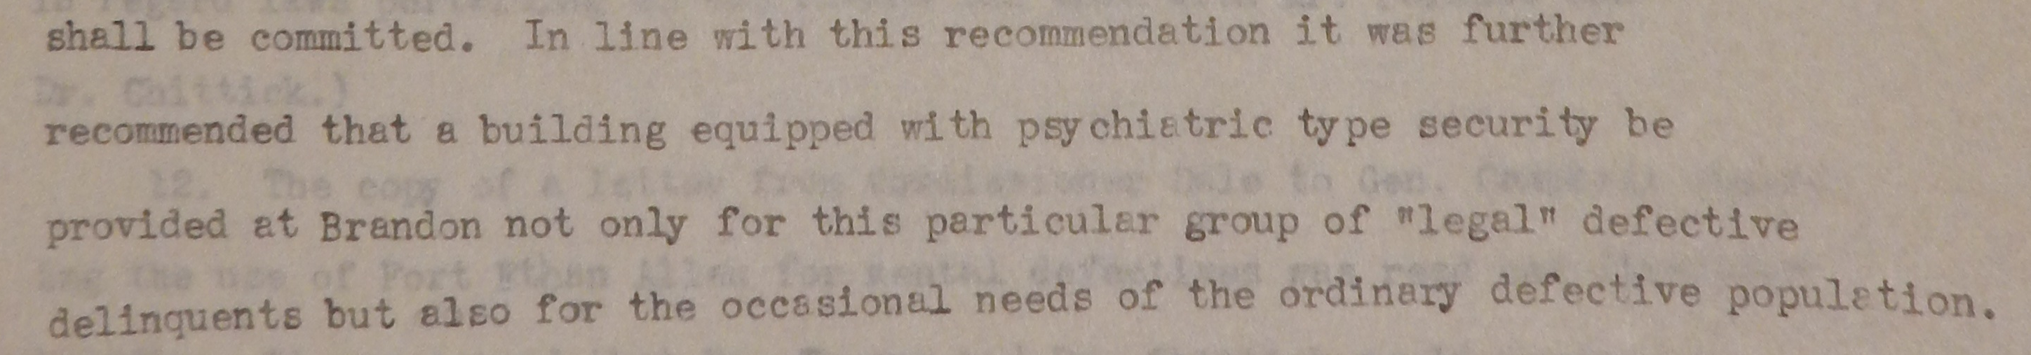

lots of discussion of what should be done with defective delinquents – some effort to specify what this term means – legal vs. medical definition – where should such defective delinquents be placed? Need to segregate them from the broader population of defectives.

Also discussion on “very young psychopaths” vs. “juvenile psychopaths” – the former can be accommodated alongside defectives at BTS, but not the latter.

Discussion as well of the non-psychotic epileptic and where he/she should be housed.

Suggestion of placement and parole options to relieve population pressures at BTS.

Following is an excerpted letter explaining the charge of the Mental Health Committee in 1946:

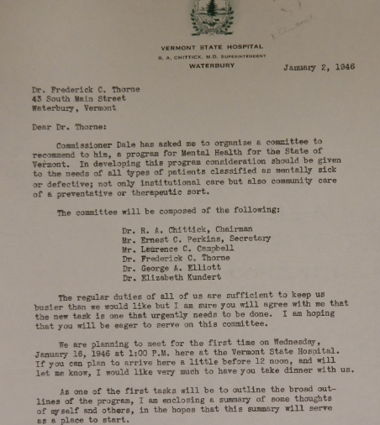

chair of the committee is Rupert A. Chittick , superintendent of the VSH

Folder: Mental Hygiene Society

Thorne mentions his resignation in 1947 in correspondence with a member of the Mental Hygiene Society:]

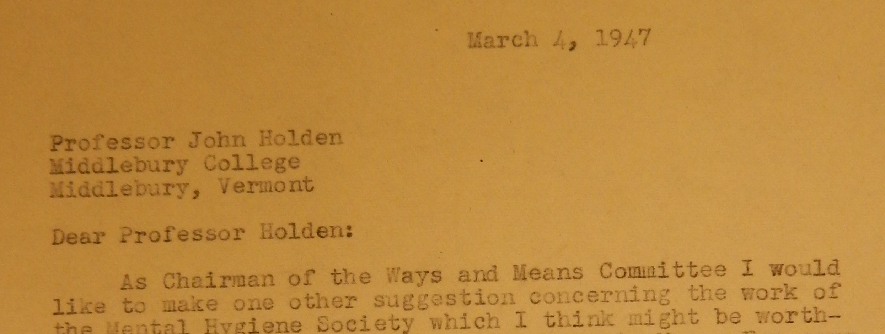
suggestion was to increase/universalize medication use to treat epilepsy throughout the state.

